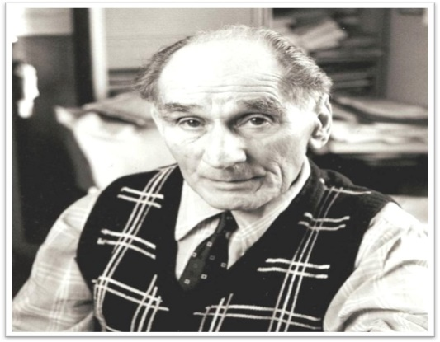

Fighting racism, standing up against hate #Leon110
Student initials: Tutor/class group:
- My title for the poem: __________________________________________________________________________

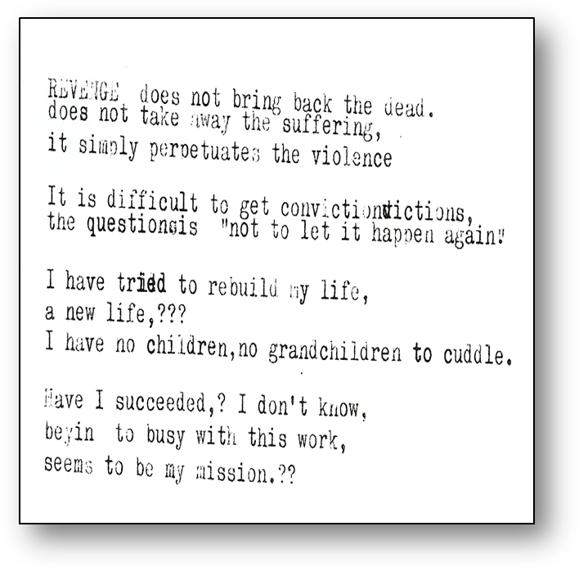

- My stanza to finish the poem: reflecting on Leon’s words, life and legacy -

2b. In my final verse, in response to Leon’s words, his life and legacy, I wanted to show/explain/discuss…

3a. In choosing the title, I wanted to show/explain/discuss:
Submit your entry to your teacher/tutor: who will select up to five to be entered and considered for the UCL Centre for Holocaust Education #Leon110 award.

