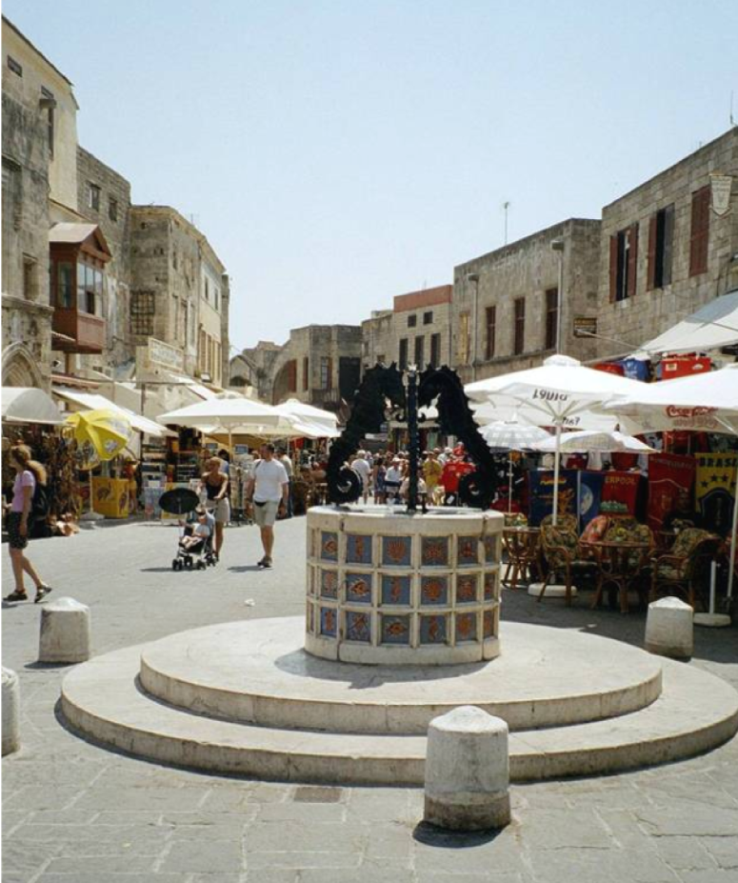

Look at this image:
- Where do you think it may have been taken?
- What is missing?

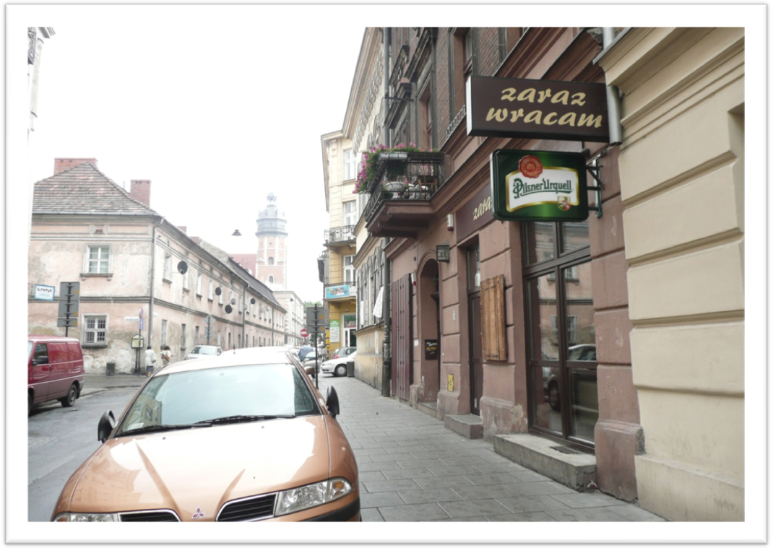
Look at this image:
- Where do you think it may have been taken?
- What is missing?

