‘Empowering Young People to Change the World’
October 6th 2015, March 18th and July 8th 2016
Conference SERIES Booking Form

DELEGATE DETAILS:

Title_______ First Name_________________________ Surname________________________________

Email address_______________________________________ Phone No._________________________

Job Title_________________________________ Twitter handle________________________________

SCHOOL / ORGANISATION DETAILS:

Name of School / Organisation____________________________________________________________

Address of School / Organisation__________________________________________________________

__________________________________________________________

__________________________________________________________

CONFERENCE REGISTRATION RATES AND PAYMENT DETAILS:

Price: £25 per person, per day.
Please tick below conference series dates you are registering for:
Developing T&L strategies that EYP2CtW | 6th October, 2015
Developing leadership, SMSC & holistic approaches that EYP2CtW | 18th March, 2016
Developing Holocaust education, genocide prevention & human rights awareness to EYP2CtW | 8th July, 2016

I enclose a cheque for £25.00/£50.00/£75.00 (payable to Royal Wootton Bassett Academy) __________

I would like my school / organisation to be invoiced. Order Number_____________________

(Please note: The registration fee is non-refundable)

Please either send to: or email to:
Rhiannon Hayden RHayden@rwba.org.uk
Royal Wootton Bassett Academy
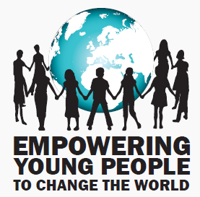
Lime Kiln
Royal Wootton Bassett
Wiltshire
SN4 7HG

Follow us on Twitter: @RWBHOLOCAUST #EYP2CtW

